Project Design Phase-II Technology Stack (Architecture s Stack)

|  |  |
| --- | --- |
| Date | 26 June 2025 |
| Team ID | LTVIP2025TMID50687 |
| Project Name | visualizing housing market trends: an analysis of sale prices and features using tableau |
| Maximum Marks | 4 Marks |

Technical Architecture:

The Deliverable shall include the architectural diagram as below and the information as per the table1 C table 2

Technical Architecture Diagram Overview

The architecture follows a **three-tier architecture**:

* **Presentation Layer:** Web C mobile interface using HTML/JS
* **Application Layer:** Python scripts, Tableau dashboards, and scheduling logic
* **Data Layer:** Cloud database + CSV inputs + Tableau extracts

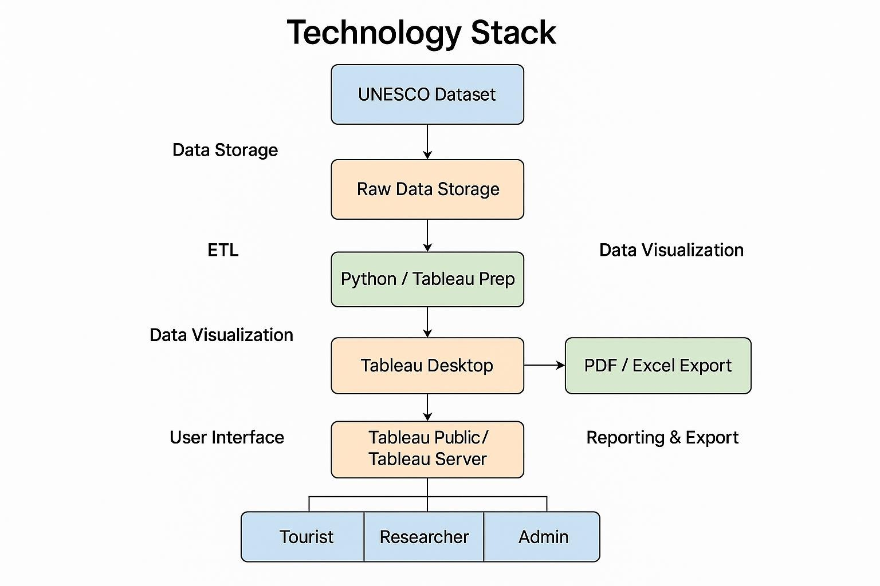

Table-1 : Components s Technologies:

|  |  |  |  |
| --- | --- | --- | --- |
| **S.No** | **Component** | **Description** | **Technology** |
| 1. | User Interface | Interface to explore dashboards via web/mobile | HTML, CSS, JavaScript ,Tableau Public. |
| 2. | Application Logic-1 | Data cleaning Ctransformation for Tableau | Python (Pandas,Numpy) |
| 3. | Application Logic-2 | Automated updates Cscheduling scripts | Python+Tableau Prep |
| 4. | Application Logic-3 | Optional chatbot for heritage queries | IBM Watson Assistant |
| 5. | Database | Primary dataset(Structured) | MySQL or PostgreSQL |
| 6. | Cloud Database | Cloud-hosted historical UNESCO data | IBM DB2 on cloud/Google Big Query. |
| 7. | File Storage | Uploaded CSV files and Tableau extract files | Google Drive/IBM Block Storage |

|  |  |  |  |
| --- | --- | --- | --- |
| 8. | External API-1 | Geolocation of heritage sites | Google Maps API |
| 9. | External API-2 | Country-wise statistics API | RESTful APIs(e.g.,World Bank). |
| 10. | Machine Learning Model | Optional NLP model for tag extraction(future phase) | HuggingFace Transformers/scikit-learn |
| 11. | Infrastructure (Server / Cloud) | Hosted Tableau dashboards on cloud. | Tableau Public/Cloud Foundry/Kubernetes. |

Table-2: Application Characteristics:

|  |  |  |  |
| --- | --- | --- | --- |
| **S.No** | **Characteristics** | **Description** | **Technology** |
| 1. | Open-Source Frameworks | Python ,Pandas ,Numpy,React (Optional for UI),Flask(for APIs) | Python ,React,Flask |
| 2. | Security Implementations | OAuth(Google,LinkedIn),data encryption,Tableau access restrictions | OAuth 2.0,IAM,HTTPS,JWT. |
| 3. | Scalable Architecture | Tiered architecture with support for cloud deployement and multiple data sources | 3-Tier Design,Tableau Cloud,Kubernetes. |
| 4. | Availability | Hosted Tableau dashboards ensure 99.9% uptime | Load balancetrs(cloud- based),Tableau Online. |
| 5. | Performance | Optimized queries,extract refresh scheduling ,and CDN for static resources | Tableau  Extracts,Redis,CDN,Scheduler |